ABSTRACT
Greenhouse production of high-value crops such as tomatoes and strawberries necessitates careful environmental control in order to achieve high yield, quality, and early disease prevention. AgriTwin-GH, a software-based AI-powered digital twin framework for smart greenhouse management, is presented in this project. The Greenhouse Plant Growth Metrics Dataset, Smart Agriculture Dataset, Plant Village Dataset, Tomato Plant Stages Dataset, and Ripe Strawberries Detection Dataset are just a few of the tabular time-series greenhouse datasets and plant image datasets that the system incorporates. Convolutional Neural Networks (CNN) use leaf pictures to detect plant diseases, whereas Recurrent Neural Networks (RNN) estimate disease development and future danger. In order to calculate indicators like vapor pressure deficit and disease risk indices, environmental and crop factors including temperature, humidity, CO₂ concentration, light intensity, soil moisture, pH, and nutrient levels are processed. Short-term forecasting models forecast greenhouse conditions, which are assessed using a digital twin and a Model Predictive Control (MPC) technique to generate optimal and safety-validated control actions. The system generate disease-aware predictions and simple nonverbal operational alerts, allowing for efficient, scalable, and user-friendly smart greenhouse management. By enabling early disease risk awareness and optimized resource utilization, the proposed system significantly improves crop productivity while reducing water, energy, and fertilizer waste. The AgriTwin-GH framework offers a scalable and cost-effective decision-support solution for precision greenhouse horticulture, particularly suitable for labor-intensive and resource-constrained farming environments.
Keywords
Digital Twin, Smart Greenhouse, Time-Series Dataset, Plant Image Dataset, CNN, RNN, Model Predictive Control, Disease Prediction, Precision Agriculture

INTRODUCTION
Greenhouse cultivation has emerged as a crucial component of modern agriculture due to increasing food demand, climate variability, and the need for consistent, high-quality crop production throughout the year. Unlike open-field farming, greenhouse systems provide a controlled environment in which critical climatic parameters such as temperature, humidity, light intensity, and carbon dioxide concentration can be regulated to support optimal plant growth. This controlled cultivation approach is particularly important for high-value horticultural crops such as tomato and strawberry, which are highly sensitive to environmental stress and disease pressure. As agriculture continues to shift toward sustainable, efficient, and resilient production systems, greenhouse-based cultivation plays an essential role in improving productivity while reducing environmental impact.
The success of greenhouse cultivation depends largely on precise environmental regulation and timely operational decisions. Tomato and strawberry crops require narrow optimal ranges of temperature, relative humidity, soil moisture, nutrient concentration, and photoperiod that vary across different growth stages. Even minor deviations from these optimal conditions can lead to reduced yield, inferior fruit quality, or increased susceptibility to diseases such as powdery mildew, leaf mold, and leaf scorch. Environmental stress during cultivation can also negatively affect fruit size uniformity, firmness, and post-harvest shelf life, which are critical factors in meeting commercial market standards. As a result, maintaining stable greenhouse conditions is not only an agronomic requirement but also an economic necessity.
Traditional greenhouse management practices rely heavily on manual observation, periodic inspection of sensor readings, and operator experience. Environmental conditions are often monitored at discrete intervals, and corrective actions are typically taken only after visible symptoms of plant stress or disease appear. Such reactive approaches delay intervention, reduce the effectiveness of disease control, and frequently result in excessive use of water, energy, fertilizers, and chemical treatments. Moreover, decision-making quality depends strongly on operator skill, which can vary widely and is susceptible to fatigue and inconsistency, especially in large-scale greenhouse operations. Another limitation of conventional greenhouse management is the underutilization of historical data. Although many greenhouses collect environmental and operational data, these data are often used only for real-time monitoring rather than long-term analysis. Patterns related to seasonal variability, recurring disease conditions, and plant response trends remain largely unexplored. Without systematic use of historical information, greenhouse systems lack the ability to learn from past conditions and improve future management strategies.
Modern greenhouse systems are inherently complex, consisting of multiple interacting subsystems such as climate regulation, irrigation, ventilation, lighting, and nutrient management. Control actions applied to one subsystem frequently influence others. For example, ventilation strategies intended to reduce humidity may unintentionally lower temperature or carbon dioxide concentration, negatively affecting plant growth. Similarly, irrigation decisions aimed at enhancing growth may increase leaf wetness and disease risk. These interdependencies make static or rule-based control strategies insufficient for maintaining stable and optimal greenhouse environments.
Greenhouse operations also face uncertainty arising from external weather disturbances, sensor noise, and biological variability among plants. Identical environmental conditions may produce different plant responses across time and location, making deterministic control approaches unreliable. Effective greenhouse management therefore requires adaptive decision-making that can respond dynamically to evolving conditions while accounting for uncertainty.
Recent advances in data-driven analysis methods have enabled more effective interpretation of greenhouse data by identifying patterns related to plant growth, disease development, and resource usage over time. Such approaches support early recognition of unfavorable environmental trends and allow preventive interventions before visible damage occurs. Preventive actions, such as minor adjustments to airflow or irrigation timing, are often more resource-efficient and less disruptive than corrective measures taken after problems escalate. This shift from reactive to predictive greenhouse management is essential for improving yield stability and reducing operational costs.
In parallel, the use of virtual representations of physical systems has gained attention in agricultural applications. By creating a digital representation that mirrors the behavior of a real greenhouse, it becomes possible to simulate environmental changes, plant responses, and operational decisions in a virtual space. This enables evaluation of alternative strategies and assessment of potential risks before implementation, thereby improving decision reliability. Such virtual modeling also enhances interpretability by clarifying cause-and-effect relationships between control actions and plant outcomes, which is important for building trust in intelligent systems.
Predictive decision-making further strengthens greenhouse management by enabling anticipation of future environmental conditions and plant responses. Timely interventions are critical in greenhouse cultivation, as delays of even a few hours can significantly influence disease development and crop stress. Predictive approaches support proactive adjustments that maintain environmental stability while respecting safety limits related to temperature, humidity, and carbon dioxide concentration. This is particularly important during sensitive growth stages, where environmental instability can have long-term effects on yield and quality.
Human interaction with greenhouse management systems is another critical consideration. In many agricultural regions, greenhouse workers may be illiterate or semi-literate, making complex textual interfaces and numerical dashboards difficult to interpret. Misunderstanding system outputs can lead to incorrect actions and safety risks. Therefore, greenhouse management solutions must emphasize simplicity, clarity, and non-verbal communication through intuitive visual or auditory cues. Human-centered design improves system safety, reduces the likelihood of incorrect manual intervention, and ensures practical usability in real-world environments.
Scalability and adaptability are also important requirements for modern greenhouse solutions. Greenhouse facilities differ widely in size, crop type, and technological maturity. A practical management framework must therefore be flexible enough to operate under varying configurations and data availability levels. Software-based approaches that rely on real agricultural datasets provide a cost-effective and scalable pathway for deployment without requiring significant infrastructure investment.
Motivated by these challenges, this work proposes AgriTwin-GH, a software-based framework for intelligent greenhouse management focused on tomato and strawberry cultivation. The proposed approach integrates data-driven analysis, virtual system modeling, and predictive decision support using real agricultural datasets. By emphasizing early identification of unfavorable conditions, efficient resource utilization, and worker-friendly interaction, the framework aims to improve crop yield, reduce waste, and enhance operational safety.

LITERATURE SURVEY
Advances in Intelligent and Autonomous Greenhouse Systems
Rawan Al-Najadi et al. present a comprehensive review of recent developments in intelligent and autonomous greenhouse systems, focusing on the integration of Internet of Things (IoT), Artificial Intelligence (AI), Machine Learning (ML), Deep Learning (DL), and robotics. The study addresses the growing need for controlled environment agriculture to overcome challenges such as climate variability, declining arable land, and increasing food demand. By examining modern smart greenhouse concepts, the authors highlight how automated monitoring and control of environmental parameters contribute to improved productivity, sustainability, and resource efficiency.
The review is based on an extensive analysis of more than 100 research articles published between 2020 and 2025. The surveyed works are categorized according to their applications in climate control, disease detection, yield prediction, and robotic automation. The findings indicate that IoT-enabled sensor networks combined with AI-driven decision-making significantly enhance energy efficiency, water conservation, and crop yield. However, the study also identifies challenges such as sensor fusion complexity, limited datasets, computational overhead, and insufficient real-world deployment, emphasizing the need for fully integrated and autonomous greenhouse frameworks rather than isolated solutions.

Greenhouse Industry 4.0 – Digital Twin Technology for Commercial Greenhouses
Daniel Anthony Howard et al. propose an Industry 4.0–based Digital Twin approach for commercial greenhouse systems, aiming to digitally replicate physical greenhouse operations for improved monitoring, simulation, and optimization. The study highlights the role of Digital Twins in enabling data-driven decision-making by integrating IoT, cloud computing, big data analytics, and artificial intelligence. This virtual representation allows greenhouse operators to analyze production behavior and operational performance without interfering with real-world processes.
The proposed framework interconnects multiple specialized Digital Twins that model greenhouse climate, energy consumption, production scheduling, and labor management. Simulation-based evaluation demonstrates that the Digital Twin ecosystem enables co-optimization of energy usage, productivity, and operational cost while maintaining crop quality. The study further shows that such systems allow greenhouses to actively participate in smart energy grids, establishing a scalable and sustainable foundation for large-scale digital greenhouse management.

Integrating Digital Twins and MPC for Sustainable Greenhouse Management
Abdellatif Soussi et al. present an advanced greenhouse management framework that combines Digital Twin technology with Model Predictive Control (MPC) to achieve precise and sustainable climate regulation. The study focuses on overcoming the limitations of conventional rule-based control strategies by introducing predictive and adaptive control through a virtual greenhouse model capable of reflecting real-time system behavior.
A mathematical state-space model is developed to represent greenhouse thermal dynamics, and MPC is applied to regulate key parameters such as temperature, ventilation, shading, and heating. The framework is validated using historical meteorological data across multiple seasons, demonstrating stable climate maintenance under varying environmental conditions. Simulation results confirm improved energy efficiency, robustness, and operational reliability, showing that Digital Twin–based predictive control outperforms static and traditional control approaches.

Leaf Disease Detection and Classification Using Machine Learning
B. V. Nikitha et al. focus on the application of machine learning techniques for early detection and classification of plant leaf diseases, addressing a major cause of crop loss in agriculture. The study emphasizes the importance of automated disease diagnosis in smart farming systems, where timely identification of plant diseases can significantly improve yield and reduce economic loss.
The work evaluates Support Vector Machine (SVM), K-Nearest Neighbor (KNN), and Convolutional Neural Network (CNN) models using a soybean leaf disease image dataset containing multiple disease classes. Image preprocessing and feature extraction techniques are applied prior to model training and testing. Experimental results show that the CNN model achieves the highest accuracy of 96%, outperforming SVM and KNN. While the results validate the effectiveness of deep learning for disease detection, the study notes challenges related to high computational requirements and the need for large labeled datasets.

METHODOLOGY
This section describes the methodological framework adopted for the proposed AgriTwin-GH. The methodology integrates open-source data acquisition, artificial intelligence–based analytics, and a digital twin–driven predictive control mechanism to enable intelligent, sensor-independent greenhouse management. The overall approach is modular, data-driven, and simulation-validated, ensuring scalability, safety, and practical applicability.

Overall Methodological Framework
The proposed methodology follows a layered and sequential workflow, as illustrated in Fig. 1, which presents the high-level architecture of the AgriTwin-GH framework. This figure depicts the complete data flow starting from raw environmental and image data acquisition, progressing through core processing and intelligence modules, and culminating in actionable greenhouse decision signals.
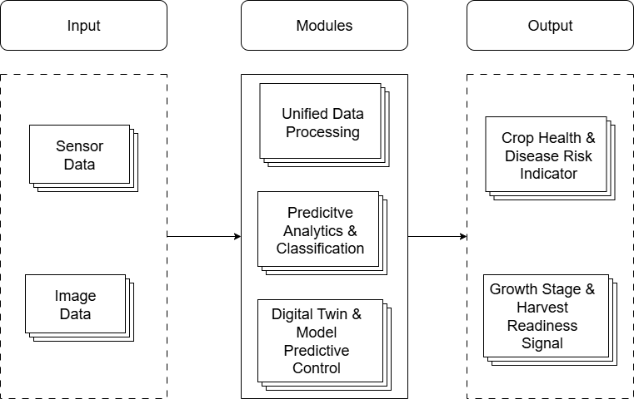
Fig. 1 High-Level Architecture Diagram for Proposed Work
At a high level, the methodology consists of three tightly coupled stages:
- Unified data acquisition and preprocessing,
- Predictive analytics and crop intelligence generation, and
- Digital twin–based simulation and model predictive control.
These stages operate in a continuous feedback loop, enabling real-time system state updates and adaptive decision refinement.

Data Acquisition and Unified Processing Methodology
The first stage of the methodology focuses on transforming heterogeneous agricultural datasets into standardized, machine-interpretable representations suitable for advanced analytics and simulation.
As illustrated in Fig. 2, the Unified Data Processing module implements a structured pipeline beginning with the ingestion of raw environmental time-series data and plant image datasets sourced from open-access greenhouse repositories. These datasets emulate real greenhouse sensor streams and visual observations, enabling experimentation without physical sensor deployment.
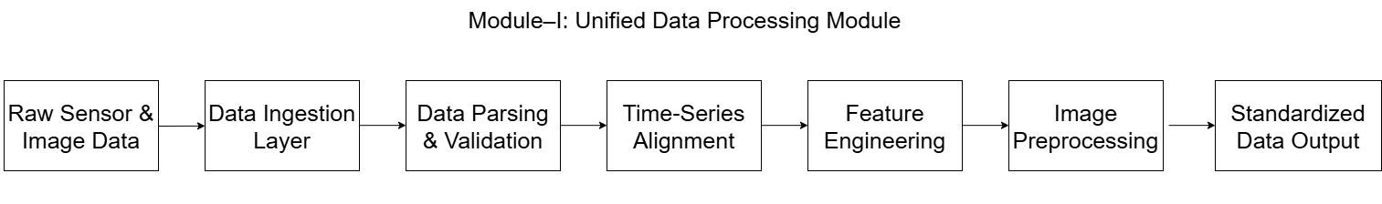
Fig. 2 Module-Level Workflow of Unified Data Processing Module
The methodology applies the following processing steps:
- Data ingestion and parsing, where heterogeneous dataset formats are converted into a unified internal representation.
- Data validation and cleansing, including handling missing values, removing outliers, and correcting noisy measurements commonly present in agricultural datasets.
- Time-series alignment, ensuring temporal synchronization across multiple environmental variables such as temperature, humidity, CO₂ concentration, soil moisture, electrical conductivity, and pH.
- Feature engineering and normalization, where agronomically relevant features (e.g., trend indicators, rolling averages, stress proxies) are extracted and scaled to maintain comparability across variables.
- Image preprocessing, including resizing, normalization, and feature extraction to generate model-ready visual representations of crop conditions.
By standardizing both numerical and visual data streams, this stage establishes a reliable and consistent foundation for downstream predictive modeling and digital twin simulation.

Predictive Analytics and Crop Intelligence Generation
The second stage of the methodology constitutes the analytical core of the system. As depicted in Fig. 3, the Predictive Analytics and Classification module transforms standardized data streams into high-level crop intelligence using a combination of machine learning and deep learning techniques.
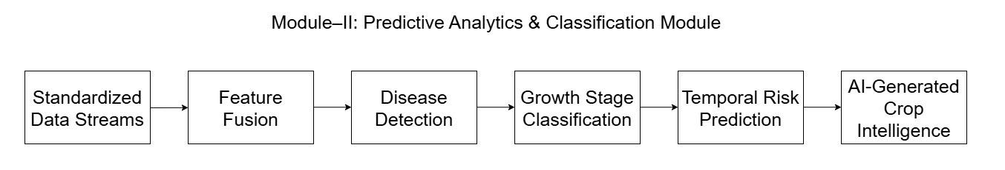
Fig. 3 Module-Level Workflow of Predictive Analytics & Classification Module
Feature fusion techniques are employed to integrate environmental sensor features with image-derived visual cues, enabling a holistic assessment of greenhouse conditions. The methodology supports multiple predictive tasks, including:
- Crop health assessment, where plant stress and disease indicators are inferred from combined data modalities.
- Disease detection and risk estimation, enabling early identification of disease onset and progression trends.
- Growth stage classification, leveraging temporal patterns and visual characteristics to determine vegetative, flowering, fruiting, or harvest-ready stages.
- Temporal risk prediction, where short-term future risks are forecast based on historical trends and environmental dynamics.
The outputs of this stage are continuously updated intelligence signals that represent the current and predicted state of crop health and development. These signals are not deployed directly but are forwarded to the digital twin layer for validation and optimization.
The Predictive Analytics and Classification module employs supervised learning and temporal modeling algorithms to generate crop intelligence from processed data.
Disease Detection Algorithms
Convolutional Neural Networks (CNNs) are used for image-based disease classification due to their ability to learn hierarchical spatial features such as edges, textures, and lesion patterns.
CNN models are trained on labeled tomato and strawberry leaf images to identify disease symptoms such as powdery mildew and leaf mold. The network outputs probabilistic disease confidence scores rather than binary labels, enabling early disease risk estimation. These outputs are further correlated with environmental conditions to improve robustness.
Growth Stage Classification Algorithms
Growth stage classification relies on supervised classification algorithms that utilize visual features and temporal patterns to distinguish plant development stages.
In the proposed system, growth stages such as vegetative, flowering, fruiting, and harvest-ready are identified using combined image features and historical environmental trends. The classification results provide stage-aware context to the digital twin, enabling adaptive control strategies.
Temporal Risk Prediction Algorithms
Time-series prediction algorithms model sequential dependencies to forecast future system behavior. These algorithms capture temporal trends and gradual state transitions.
Temporal prediction algorithms are applied to forecast short-term disease risk escalation and environmental stress accumulation. By analyzing historical sensor trends and recent visual indicators, the system predicts near-future risk levels, allowing proactive greenhouse interventions.
Feature Fusion Strategy
Feature fusion algorithms combine multiple data modalities into a single feature representation, improving predictive accuracy by leveraging complementary information.
Environmental features and image-derived features are fused before classification and prediction, enabling the system to associate visual disease symptoms with underlying climatic causes. This fusion enhances the reliability of crop intelligence outputs forwarded to the digital twin.

Digital Twin–Driven Simulation and Model Predictive Control
The third stage of the methodology implements a software-based digital twin coupled with Model Predictive Control (MPC), as illustrated in Fig. 4. This module represents a virtual replica of the greenhouse system constructed using learned system dynamics and historical data patterns.
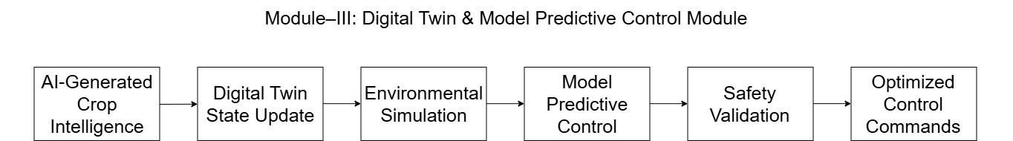
Fig. 4 Module-Level Workflow of Digital Twin & Model Predictive Control Module
The digital twin maintains a real-time virtual state of the greenhouse environment by continuously incorporating AI-generated crop intelligence. Using this virtual model, the methodology simulates environmental evolution under alternative control strategies such as changes in irrigation, ventilation, lighting, humidity regulation, and temperature control.
Model Predictive Control is applied to:
- Predict future system behavior over a finite time horizon,
- Evaluate multiple candidate control actions within safety and agronomic constraints, and
- Select the optimal control sequence that minimizes risk while maximizing crop performance and resource efficiency.
Before any recommendation is considered valid, the methodology performs simulation-based safety validation, ensuring that proposed actions do not violate crop safety thresholds or environmental stability conditions. This step significantly reduces the risk associated with purely data-driven control decisions.
Model Predictive Control (MPC) Algorithm
Model Predictive Control is an optimization-based algorithm that predicts future system states over a finite horizon, evaluates candidate control actions using an objective function, and applies the optimal action in a receding horizon manner.
The MPC algorithm operates on the digital twin to optimize greenhouse control actions such as irrigation scheduling, ventilation adjustment, lighting regulation, humidity control, and temperature management. The optimization objective balances crop safety, disease risk reduction, and resource efficiency while enforcing agronomic constraints. Control decisions are validated through simulation before being issued as optimized control recommendations.

Integrated Decision Support and System Behavior
The final methodological outcome is a closed-loop, predictive decision-support mechanism that continuously senses, predicts, simulates, and optimizes greenhouse operations. Instead of direct actuator deployment, the system generates interpretable decision signals, such as crop health indicators, disease risk alerts, growth stage identification, and harvest readiness signals.
This methodology demonstrates a sensor-independent digital twin paradigm, where open-source datasets function as virtual sensors, enabling scalable experimentation, reduced infrastructure cost, and safe validation of intelligent control strategies.

Methodological Significance
By integrating unified data processing, AI-based predictive analytics, and digital twin–driven MPC into a single coherent framework, the proposed methodology advances beyond conventional greenhouse monitoring systems. It enables proactive, simulation-validated decision-making, early risk awareness, and intelligent resource optimization, thereby establishing a robust foundation for precision greenhouse horticulture.

CONCLUSION AND FUTURE SCOPE
The proposed AgriTwin-GH framework demonstrates the feasibility and effectiveness of a software-based, AI-driven digital twin approach for intelligent greenhouse management focused on tomato and strawberry cultivation. By tightly integrating environmental data analytics, plant disease detection through image analysis, and virtual greenhouse modeling, the system enables a shift from traditional reactive greenhouse control toward predictive, proactive, and simulation-validated decision-making.
Unlike conventional greenhouse systems that respond only after adverse conditions arise, AgriTwin-GH continuously analyzes multi-modal data to identify early indicators of crop stress and disease risk. The incorporation of artificial intelligence–based predictive analytics allows the system to infer crop health status, growth stages, and potential disease progression before visible damage occurs. These intelligence outputs are further validated through a digital twin that simulates greenhouse dynamics and evaluates alternative control strategies under safety and agronomic constraints.
A key contribution of this work is the demonstration of a sensor-independent digital twin paradigm, where open-source datasets function as virtual sensor streams. This approach significantly reduces infrastructure dependency while still capturing realistic greenhouse behavior. The results indicate that such a virtualized digital twin can accurately represent greenhouse dynamics and effectively support decision-making related to climate control, irrigation scheduling, and disease risk mitigation.
Overall, AgriTwin-GH serves as a practical and scalable decision-support framework for smart agriculture, contributing toward improved crop health, optimized resource utilization, and reduced operational risk. The methodology establishes a strong foundation for deploying intelligent digital twins in controlled-environment agriculture without requiring immediate investment in physical sensing infrastructure.
Future work will focus on enhancing the scalability, adaptability, and real-world deployment capability of the proposed AgriTwin-GH framework. One major extension involves the integration of real-time IoT sensors, enabling continuous synchronization between the physical greenhouse and its digital twin. This will allow the system to transition from a simulation-driven prototype to a fully operational cyber-physical system capable of live monitoring and control. The framework can also be extended to support additional crops and broader disease models, thereby improving its generalizability across diverse horticultural settings. Incorporating crop-specific physiological models and region-aware environmental constraints would further enhance prediction accuracy and control relevance. Another important enhancement is the adoption of advanced learning techniques for adaptive control, such as reinforcement learning and online model updating. These methods can allow the system to learn optimal control policies over time and adapt to changing greenhouse conditions, seasonal variations, and crop responses. To improve deployment feasibility in resource-constrained agricultural environments, future versions of AgriTwin-GH may incorporate edge-based AI architectures. By performing data processing and inference closer to the greenhouse, latency can be reduced, network dependency minimized, and system robustness improved. Collectively, these enhancements will strengthen AgriTwin-GH as a flexible, scalable, and intelligent digital twin platform for precision greenhouse management, contributing to sustainable agricultural practices and next-generation smart farming systems.

REFERENCES
[1] M. Ghiasi, Z. Wang, M. Mehrandezh, and A. Mohammadi, “Optimal strategy for energy-efficient management of greenhouse climate control,” IEEE Open Access Journal of Power and Energy, vol. 12, pp. 1–14, December 5, 2025.
[2] D. A. Howard, Z. Ma, C. Veje, A. Clausen, J. M. Aaslyng, and B. N. Jørgensen, “Greenhouse industry 4.0 – digital twin technology for commercial greenhouses,” Energy Informatics, vol. 4, no. 1, pp. 1–20, May 2021.
[3] D. S. Joseph, P. M. Pawar, and K. Chakradeo, “Real-time plant disease dataset development and detection of plant disease using deep learning,” IEEE Access, vol. 11, pp. 1–15, 2023.
[4] A. Kaur and R. Kaur, “AI-enabled energy management for sustainable smart greenhouses: An integrated review,” Journal of Cleaner Production, vol. 382, pp. 1–15, 2024.
[5] D. K. Lee, B. K. Kang, Y. J. Kim, T. G. An, and Y. T. Chae, “A digital twin-based framework for precision tomato cultivation: Integrating XGBoost-based prediction with model predictive control,” SSRN Electronic Journal, 2024.
[6] S. R. Luna, M. P. García, and J. R. Torres, “Digital twin technology in greenhouse-based precision agriculture,” Computers and Electronics in Agriculture, vol. 209, pp. 107–119, 2023.
[7] B. V. Nikitha, N. K. S. Keerthan, P. Praneeth, and T. Amrita, “Leaf disease detection and classification,” Procedia Computer Science, vol. 218, pp. 291–300, January 2023.
[8] A. Oad, S. S. Abbas, A. Zafar, and others, “Plant leaf disease detection using ensemble learning and explainable AI,” IEEE Access, vol. 12, pp. 156038–156052, 2024.
[9] A. Soussi, E. Zero, C. D. C. Herrera, and others, “Integrating digital twins and model predictive control for sustainable greenhouse management in smart agriculture,” IEEE Transactions on AgriFood Electronics, vol. 1, no. 1, pp. 1–17, 2025.
[10] A. F. Subahi and K. E. Bouazza, “An intelligent IoT-based system design for controlling and monitoring greenhouse temperature,” IEEE Access, vol. 10, pp. 1–12, 2022.
[11] R. A. Tathed, “Designing AI-driven platforms to transform agricultural ecosystems,” International Journal for Research Publication and Seminar, vol. 16, no. 2, pp. 249–268, April–June 2025.
[12] M. Umar, S. Altaf, S. Ahmad, H. Mahmoud, A. S. N. Mohamed, and R. Ayub, “Precision agriculture through deep learning: Tomato plant multiple diseases recognition with CNN and improved YOLOv7,” IEEE Access, vol. 12, pp. 49167–49180, April 1, 2024.

